**LAPORAN PRAKTIKUM**

**BGP (DYNAMIC ROUTING) MicroTik**



Nama : M. Satriyo Aji

NRP : 2110181027

**POLITEKNIK ELEKTRONIKA NEGERI SURABAYA**

**TAHUN PELAJARAN 2019/2020**

**DESAIN JARINGAN**

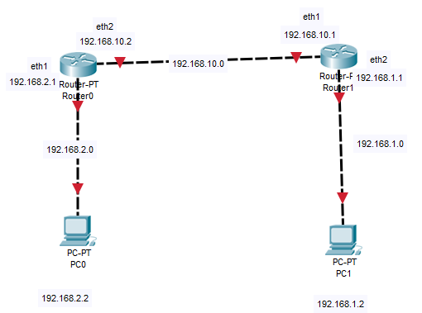

eth1

eth2

**Setting di PC0**

1. Setting nomor IP di router0 di tiap interface

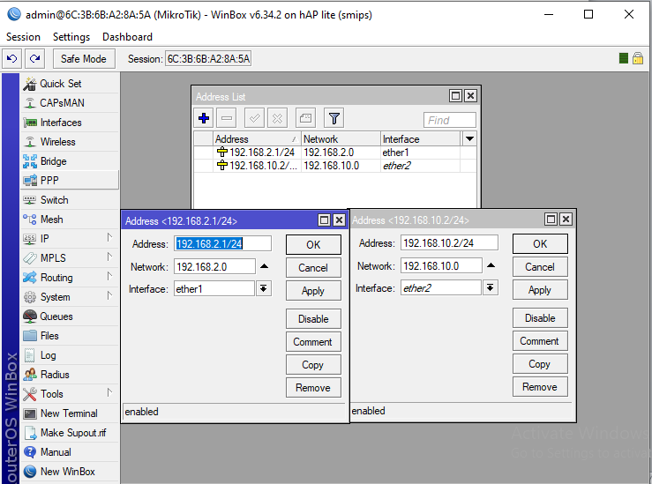

1. Setting Routing BGP di Router0
2. Intances

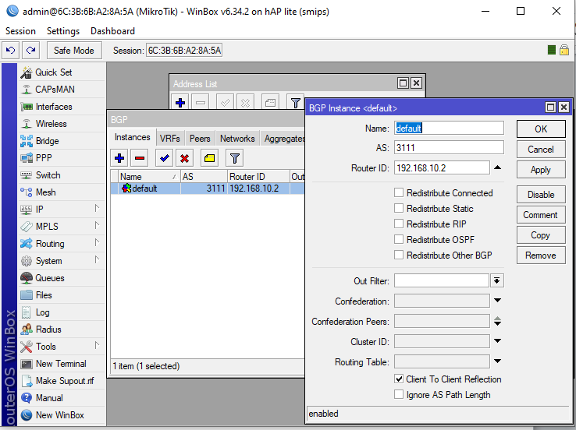

1. Peer

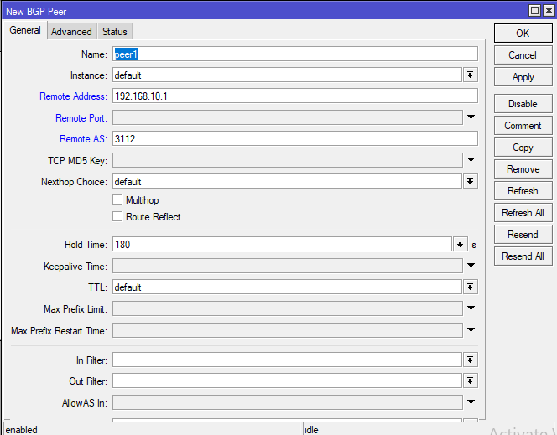

1. Networks

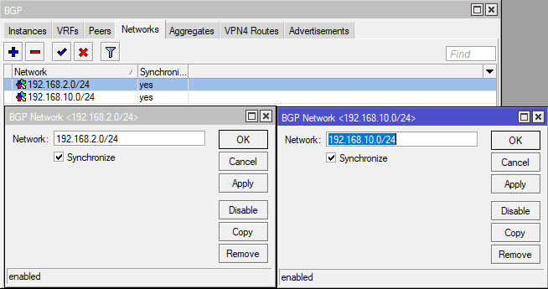

1. Setting nomor IP di PC0

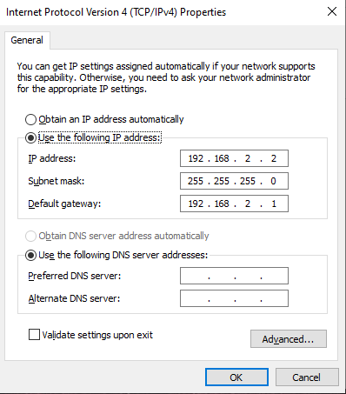

1. Show IP Route

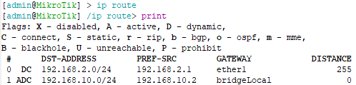

1. Ping dari PC0

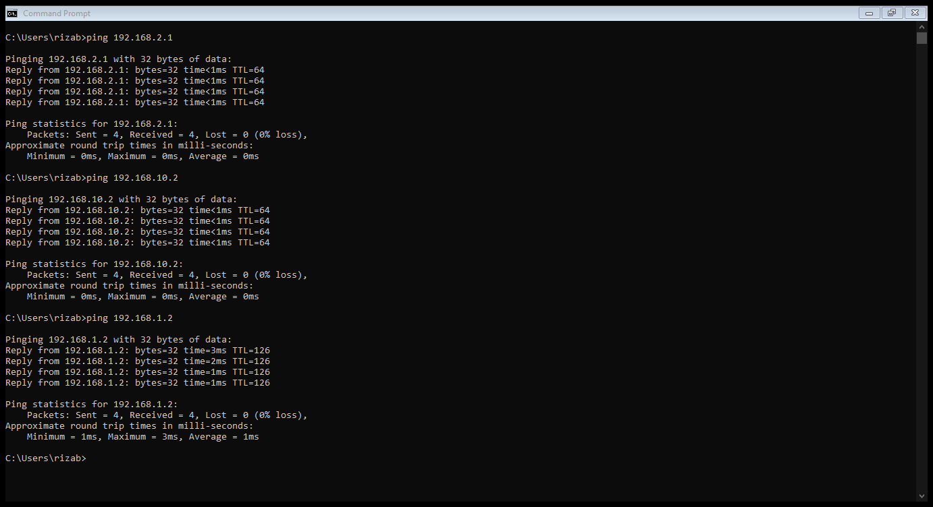

**Setting di PC1**

1. Setting nomor IP di router1 di tiap interface

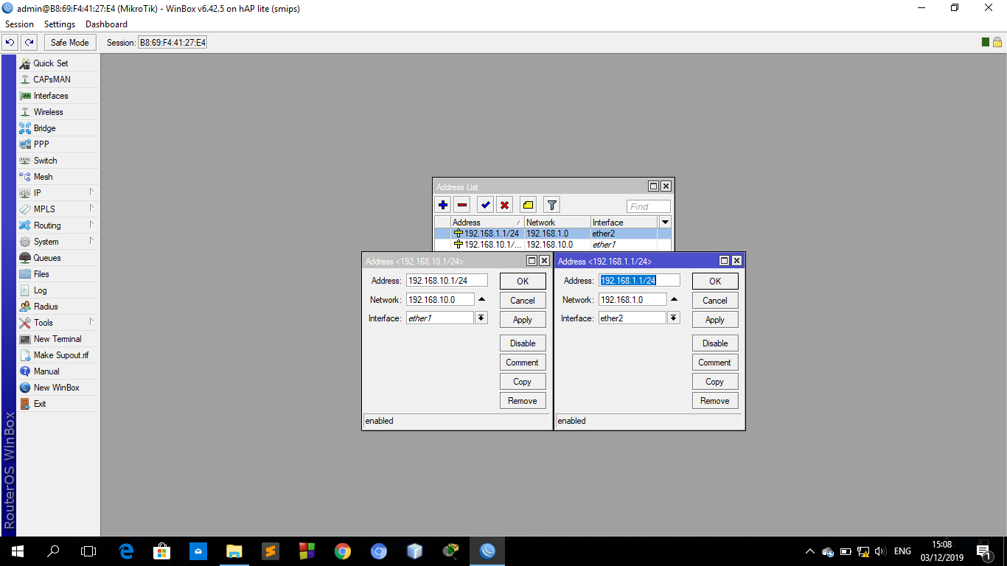

1. Setting Routing BGP di Router0
2. Instances

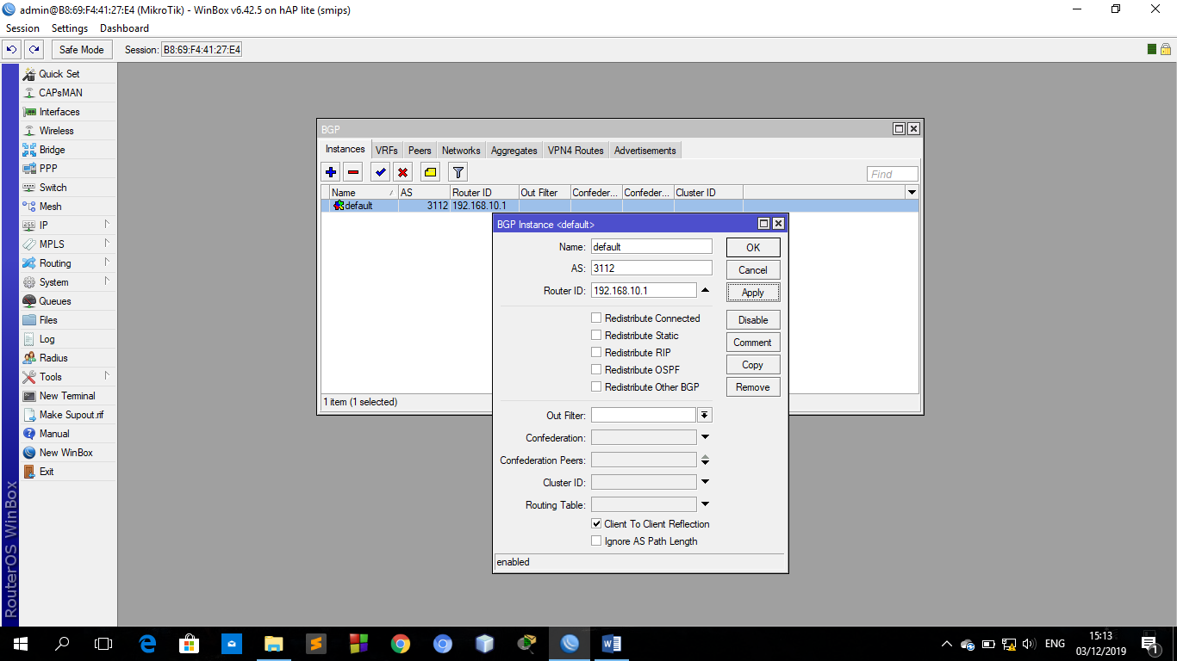

1. Peer

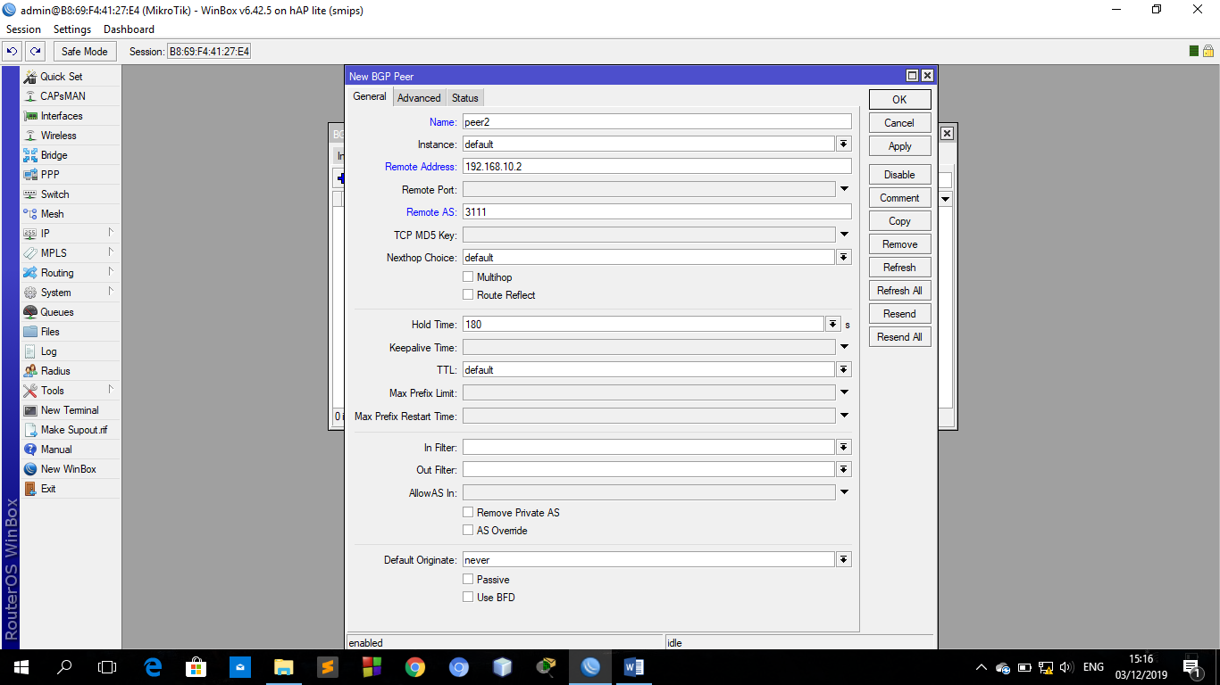

1. Networks

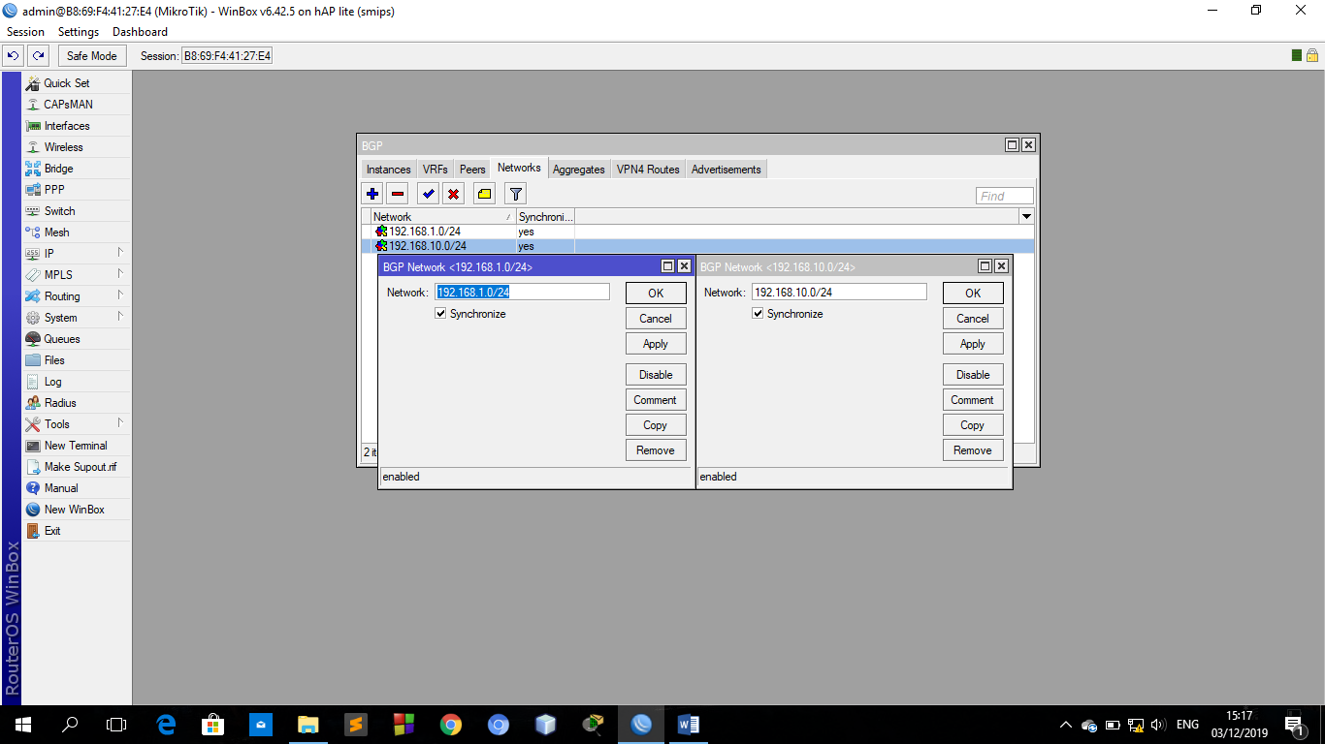

1. Setting nomor IP di PC1

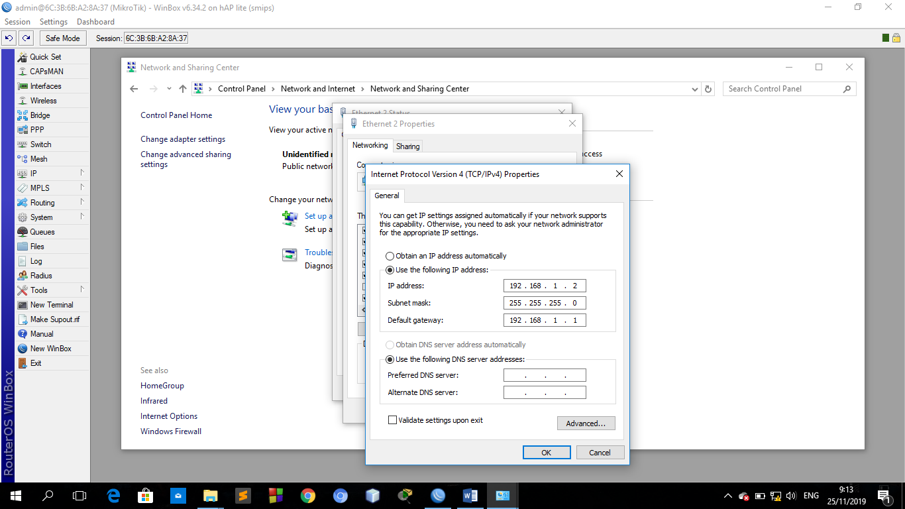

1. Show IP Route

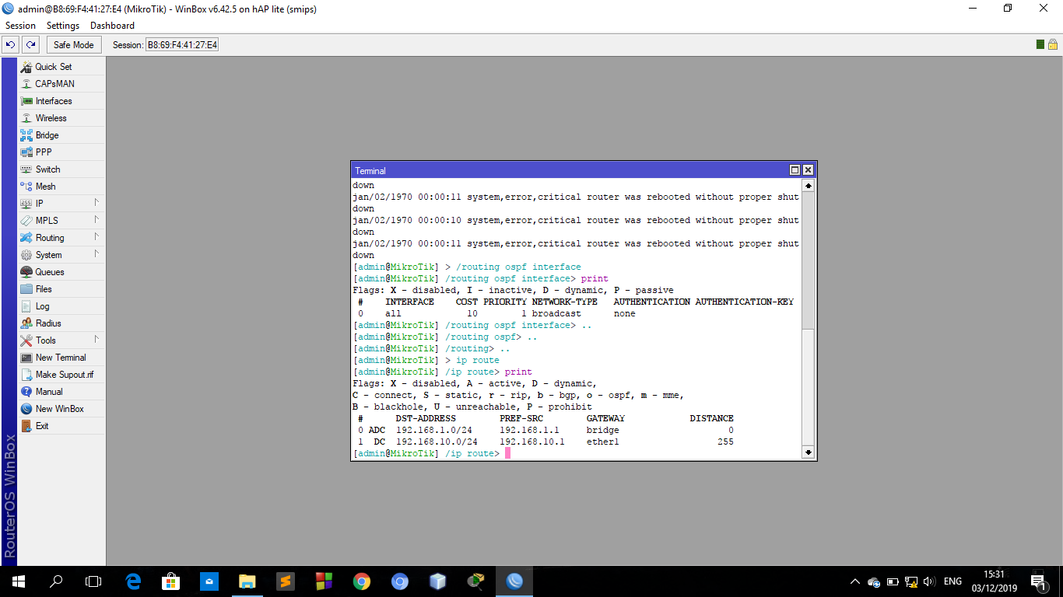

1. Ping dari PC1

